

**INCIDENT REPORTING POLICY**

Table of Contents

1. Purpose and Objective 3

2. Scope 3

3. Definitions and Abbreviations 3

4. Policy 4

5. Procedures 5

5.1 Designated Emergency Response Team (ERT) 5

5.2 Incident Reporting Procedures 5

5.3 Incident Reviews and Analysis 7

5.4 Emergency Client Transfer Procedure & Plan 8

5.5 First Aid and CPR 9

6. Related References / Documents 10

7. Amendments 10

8. Attachments 10

Attachment A - Policy Authorization Page 11

# 1. Purpose and Objective

1.1 Maharat Learning Center (MLC) committed to provide a safe environment for employees, clients and visitors. As such, all employees should understand the process in case an incident, injury, accident or near miss occurs, and what to do in case of immediate transfer of clients to a hospital in the event of a medical emergency, hence this Incident Reporting Policy has been created to provide clear instructions, guidelines, responsibilities and reporting lines.

1.2 MLC is committed to dedicate necessary resources to ensure that all employees, clients and visitors are protected from injury, health and safety hazards, and that staff are adequately trained and educated on the fundamental components of incident reporting.

1.3 The purpose of this Incident Reporting Policy is to:

* Define incidents, accidents, injuries and near misses.
* Identify procedures to report incidents, accidents, injuries and near misses.
* Reduce the risk of safety related incidents by proactively evaluated systems in place and making necessary changes through the leadership and departmental participation.
* Identify procedures and responsibilities in case of emergency transfer of clients.

# 2. Scope

2.1 The Incident Reporting Policy applies to all MLC properties and to all employees and consultants working on MLC premises, as well as clients and visitors to MLC.

# 3. Definitions and Abbreviations

3.1 **MLC:** Maharat Learning Center

3.2 **CEO/MD:** Chief Executive Officer/Managing Director

3.3 **QCBD:** Quality Compliance & Business Development Manager

3.4 **HR:** Human Resources

3.5 **ERT:** Emergency Response Team

3.6 **HSE:** Health, Safety and Environment

3.7 **DHCC:** Dubai Healthcare City

3.8 **DHA:** Dubai Health Authority

3.9 **CPQ:** Center for Healthcare Planning and Quality

3.10 **Incident:** Work related events in which an injury or ill health (regardless of severity) or fatality could have occurred. Events that give rise to an accident or have the potential to lead to an accident.

3.11 **Accident:** An undesired event giving rise to death, ill health, damage or other loss

3.12 **Near Miss:** An accident where no ill health, injury, damage, or other loss occurs is also referred to as a “near-miss”

3.13 **Injury:** Injury is damage to the body caused by external force. This may be caused by accidents, falls, hits, weapons, and other causes

# 4. Policy

4.1 It is the responsibility of all individuals at MLC to understand, follow and implement this policy and associated procedures outlined herein.

4.2 The Center Manager is the assigned HSE representative in-charge and is responsible for ensuring that the elements of this policy are implemented, under the guidance and management of the Chief Executive Officer/Managing Director (CEO/MD) and leadership team.

4.3 The CEO/MD shall ensure the availability of sufficient staff and other resources to maintain and implement the Incident Reporting Policy. The CEO/MD and leadership shall ensure compliance to all HSE regulatory requirements.

4.4 It is the responsibility of the HSE representative in-charge to ensure that;

* This document is updated, reviewed and communicated regularly.
* All staff are educated on applicable HSE issues including Incident Reporting.
* ERT staff members understand their roles and responsibilities relating to incidents and emergency transfer of clients.
* Together with management and other departments’ representatives, develop any action plans required based on the findings obtained from incident reports.
* Review and communicate to the management all summaries of property damage, occupational illness, accidents or injuries to clients, visitors and/or personnel.
* Summary reports of incident shall include evaluation of the incidents, conclusions, recommendations and actions taken on a monthly basis.

4.5 This policy contains procedures and guidelines on the following HSE related elements:

* Emergency response team – designees and responsibilities
* Incident reporting procedures
* Emergency client transfer procedures

4.6 In addition to this document, The Centers maintain detailed policies and procedures that address the following:

* Health, Safety & Environment Policy (HSE001)
* Infection Control Policy (HSE002)
* Environmental Cleaning and Waste Management Policy (HSE003)
* Risk Management Policy & Plan (QM003)
* Quality Management Policy (QM002)
* Quality Improvement Plan (QM015)
* Employee Internal Guidelines (HR028)

# 5. Procedures

## 5.1 Designated Emergency Response Team (ERT)

5.1.1 MLC has designated the following staff as the Emergency Response Team (ERT):

|  |  |  |
| --- | --- | --- |
| **EMPLOYEE** | **TITLE** | **ERT DESIGNATION** |
| Nicola Parker | Center Manager | Emergency Response Team Coordinator/Fire Warden |
| Karen Evans | QCBD Manager | Emergency Response Team Support (back up Fire Warden) |
| Joseph Mondigo | IT Technician | Emergency Response Team Support |
| Nova Granada | Housekeeper | Emergency Response Team Support/First Aider |
| Keenslee Lopez | IT & Social Media Coordinator | Emergency Response Team Support |

At MLC,the **Center Manager** is the designated Emergency Response Team Coordinator in charge during any emergency situation. In the absence of Center Manager, emergencies should be notified to **a member of the ERT team**.

5.1.2 The responsibilities of the ERT shall include, but is not limited to:

* Assisting staff if any incidents, accidents or injuries happen at the Center.
* Responding to and following the procedures for emergency transfer of clients and emergency evacuations.
* Administering First Aid and CPR (if trained to do so).
* Contacting emergency services in the event of emergency situations (including fire emergencies and medical emergencies).

5.1.3 The contact details of the ERT are visibly posted at throughout the Center on the Emergency Response Team Notice (HSE006).

## 5.2 Incident Reporting Procedures

5.2.1 The Center is committed to providing a safe environment for our staff, clients and visitors and as such all employees should understand the process in case an incident, injury, accident or near miss occurs, these are defined as:-

* **Injury:** Injury is damage to the body caused by external force. This may be caused by accidents, falls, hits, weapons, and other causes. Injuries may also include bites, scratches, scrapes, or cuts.
* **Accident:** An undesired event giving rise to ill health, damage or other loss. Accidents may include slips, trips, or falls.
* **Incident:** Work related events in which an injury or ill health (regardless of severity) or ‘incident’ could have occurred. Events that give rise to an accident or have the potential to lead to an accident. Incidents could be, but are not limited to, a lost child, a staff altercation, vandalism, theft, or occupational exposure.
* **Near Miss:** An accident where no ill health, injury, damage, or other loss occurs is also referred to as a “near-miss”. A near miss is an unplanned event that did not result in injury, illness, or damage – but had the potential to do so.

5.2.2 In the case an incident, injury, accident or near occurs, whether involving a child or an employee, it is the responsibility of the employee to follow Incident Action Plan as detailed below and the Incident Action Plan Notice (HSE005) which is posted throughout the Center.

* **Control the Situation:** This means you must stay calm and if a child is involved, keep the child calm.  You must assess and evaluate the situation to determine if first aid is required or if you need to call for emergency assistance.  If you must leave the room, you must locate and secure another staff person to stay with your child before leaving the room.
* **Apply First Aid/Call for Emergency Help:** If the incident requires first aid (bandages, ice pack, etc.) that you are able to apply yourself or with the assistance of a staff person, then you may proceed to do so.  If the incident requires emergency assistance, you must call for help.  Every room at the Center has a list of the Emergency Response Team names and emergency contact numbers posted on the wall for you to utilize as the situation requires.
* **Report the Incident:** If the incident involves a child, whether in the center, at home, at school, or on an outing, the parents must be informed of the incident.  Staff should refer to the following guidelines when reporting an incident:
* **Involving a child at the Center** - inform Client Relations at MLC, who will contact the parents.
* **Involving a child in the residence** - inform the parents/caregiver immediately and inform Client Relations at MLC.
* **Involving a child at school** - inform teacher and/or school nurse, who will contact the parents and inform Client Relations at MLC.
* **Involving a child on an outing** - inform Client Relations at MLC, who will contact the parents.
* **Involves an employee and does not involve a child** - contact HR at MLC and report the incident.
* **Does not involve a person or is a ‘near miss’** (such as utility failure, water leak, or maintenance issue) contact the Center Manager and/or QCBD Manager at MLC.
* **Document the Incident:** An Incident Report Form must be completed on the CRM system for all incidents, accidents, injuries and near misses regardless of where they occur, within 24 hours of the occurrence.  If an employee is unable to access the CRM system, an Incident Report Form (HSE004) is available at the Front Reception Desk.

If an employee is offsite, employees are required to call the applicable department as per the guidelines above and report the incident, and complete the form on the CRM system.

5.2.3 The Center Manager is responsible for reporting all incidents to the QCBD Manager. The Human Resources Department is responsible for reporting all employee related incidents to the HR Manager, and where applicable, for quality improvement and/or risk management requirements, the HR Manager will report incidents to the QCBD Manager.

## 5.3 Incident Reviews and Analysis

5.3.1 In order to minimize incidents, accidents, injuries and near misses where possible, and as part of the Risk Management Policy and Plan (QM003), MLC adopt an integrated comprehensive proactive and reactive approach designed to oversee all aspects of risk identification, risk evaluation and coordination of corrective action implementation.

5.3.2 As part of the Risk Management Policy and Plan (QM003), the reactive approaches of risk management uses the incident reporting systems adopted by MLC to provide a mechanism of identification, tracking and follow up of all incidences that pose an actual safety risk to clients, families, visitors and staff.

5.3.3 Incident reports shall be reviewed and analyzed by the Center Manager and QCBD Manager on a monthly basis and required action and feedback shall be provided to individuals involved in the incident. Reviews will be communicated to the CEO/MD and applicable HODs including all summaries of property damage, occupational illness, accidents or injuries to clients, visitors and/or personnel.

* + 1. Together with management and other departments’ representatives, the Center Manager and QCBD Manager will develop any action plans required based on the findings obtained from incident reports and implement and document improvement processes as required and update the risk management plan. All continuous quality improvement initiatives shall be communicated to staff and clients. Further information relating to incident review and analysis can be found in the Risk Management Policy & Plan (QM003).

## 5.4 Emergency Client Transfer Procedure & Plan

5.4.1 In cases of emergency transfer of clients, MLC have made arrangements with Sulaiman Al Habib Hospital to provide ambulance services in case of emergency transfer of their clients.

Preferred Treatment Location Name:

**Sulaiman Al Habib Hospital**

**04-429-7777**

**24 Hours**

**OR CALL 999**

5.4.2 Staff discovering a Medical Emergency should immediately notify one of the Centers ERT members and stay with the casualty until medical help arrives.

5.4.3 The **ERT Coordinator** is responsible for:

* Requesting first aid/CPR trained ERT personnel to respond to the scene. Refer to the Emergency Response Team (ERT) list.
* Calling the ambulance services at Sulaiman Al Habib Hospital OR 999 and should give the following information:
  + - Building number and address, including the nearest cross street(s)
    - Company Name
    - Exact location within the building
    - Your name and phone number
    - Nature of the emergency and information (where possible) in the casualty
    - Do not hang up until advised to do so by the dispatcher
  + Meet arriving ambulance services/medical aid unit and direct them to the scene.

5.4.4 **ERT first-aid/CPR trained personnel** are responsible for:

* Providing first aid/CPR care consistent with the level of training.
* First aid supplies are located in Reception area and in the Kitchen area.
* There should be one person directing resuscitation measures. This is the key to avoiding confusion and tragedy. The person attending the client should assume this role until an ambulance arrives on the scene. The Person should direct operations until ambulance arrives. .
* Keeping the casualty warm with a coat or blanket
* Not moving the casualty unless there is danger of further injury
* Staying with the casualty until medical help arrives.
* Providing information to ambulance services/medical aid unit when they arrive on the condition of the casualty
  + 1. **Other ERT members** are responsible for:
* Advising the client’s relatives of the situation and where the client is being transferred for further medical assistance.
* The caller should inform security of the nature of the emergency and the exact location.
* Only people immediately involved in the emergency should be in the area. Unnecessary crowds add to confusion and hinder resuscitation efforts. An ERT member should disperse crowds and keep corridors free.

5.4.6 Following the emergency client transfer, an incident report form should be filed by the ERT members and all those involved in the occurrence, and incident reporting, review and analysis procedures as described herein should be followed.

5.4.7 A clear and concise flowchart detailing the above plan – Emergency Client Transfer Plan Notice (HSE022) is posted throughout the center and all staff allocated responsibilities relating to the emergency client transfer plan have been provided training to understand their roles and responsibilities.

## 5.5 First Aid and CPR

5.5.1 The Center follows the latest First Aid and CPR guidelines published by American Heart Association.

5.5.2 Client facing staff is trained in First Aid and CPR, and trained members of staff are responsible for first aid appliance and attending to cardiac arrest situations. Records of training are held by the HR Department.

5.5.3 First Aid boxes are provided at the Center and are located in the following areas:-

* Kitchen service area
* In Corridor next to Male/Female Toilets

5.5.4 In case of cardiac arrest, CPR responders shall follow the steps below;

* Call for help or ask someone else to do so.
* Try to get the person to respond; if he/she doesn't, roll the person on his or her back.
* Start chest compressions. Place the heel of your hand on the center of the victim's chest. Put your other hand on top of the first with your fingers interlaced.
* Press down so you compress the chest at least 2 inches in adults and children and 1.5 inches in infants. ''One hundred times a minute or even a little faster is optimal," Sayre says. *(That's about the same rhythm as the beat of the Bee Gee's song "Stayin' Alive.")*
* If you're been trained in CPR, you can now open the airway with a head tilt and chin lift.
* Pinch closed the nose of the victim. Take a normal breath, cover the victim's mouth with yours to create an airtight seal, and then give two, one-second breaths as you watch for the chest to rise.
* Continue compressions and breaths -- 30 compressions, two breaths -- until help arrives.

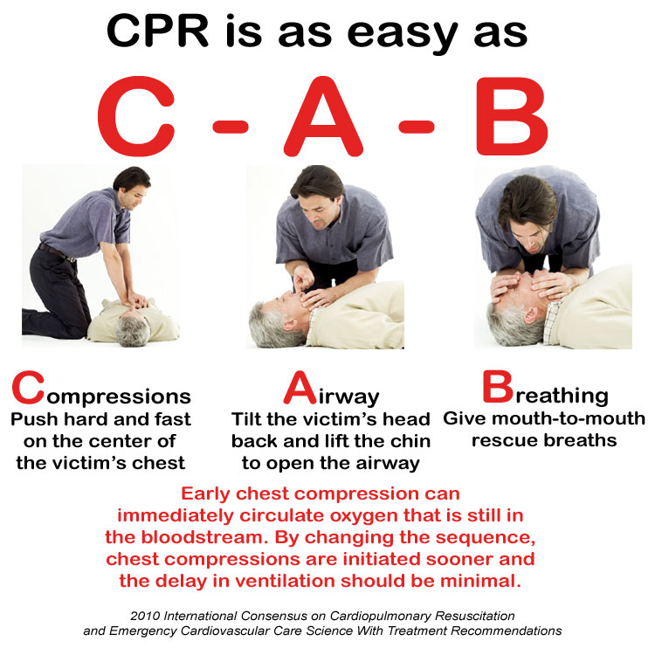

# 6. Related References / Documents

|  |  |
| --- | --- |
| HSE001 | Health, Safety & Environment Policy |
| HSE002 | Infection Control Policy |
| HSE003 | Environmental Cleaning and Waste Management Policy |
| HSE004 | Incident Report Form |
| HSE005 | Incident Action Plan Notice |
| HSE022 | Emergency Client Transfer Plan Notice |
| QM002 | Quality Management Policy |
| QM003 | Risk Management Policy & Plan |
| QM015 | Quality Improvement Plan |
| HR028 | Employee Internal Guidelines |

# 7. Amendments

7.1 This policy will be reviewed every two years at a minimum, or as required.

# 8. Attachments

8.1 Attachment A: Incident Action Plan Notice

# Attachment A - Policy Authorization Page

|  |  |  |  |
| --- | --- | --- | --- |
| **Creation Date: January 2017 Created By: Karen Evans** | | | |
| **Revision Date** | **Edited By** | **Version Number** | **Next Review Date** |
| **October 2018** | **Karen Evans** | **V.1** | **October 2020** |

**Approval Signatory:**

**Name: Dr. Hibah Shata**

**Designation/Title: Chief Executive Officer/Managing Director**

**Date: 01 October 2018**

**Signature:__________________________________________________________**

**Company Stamp:**